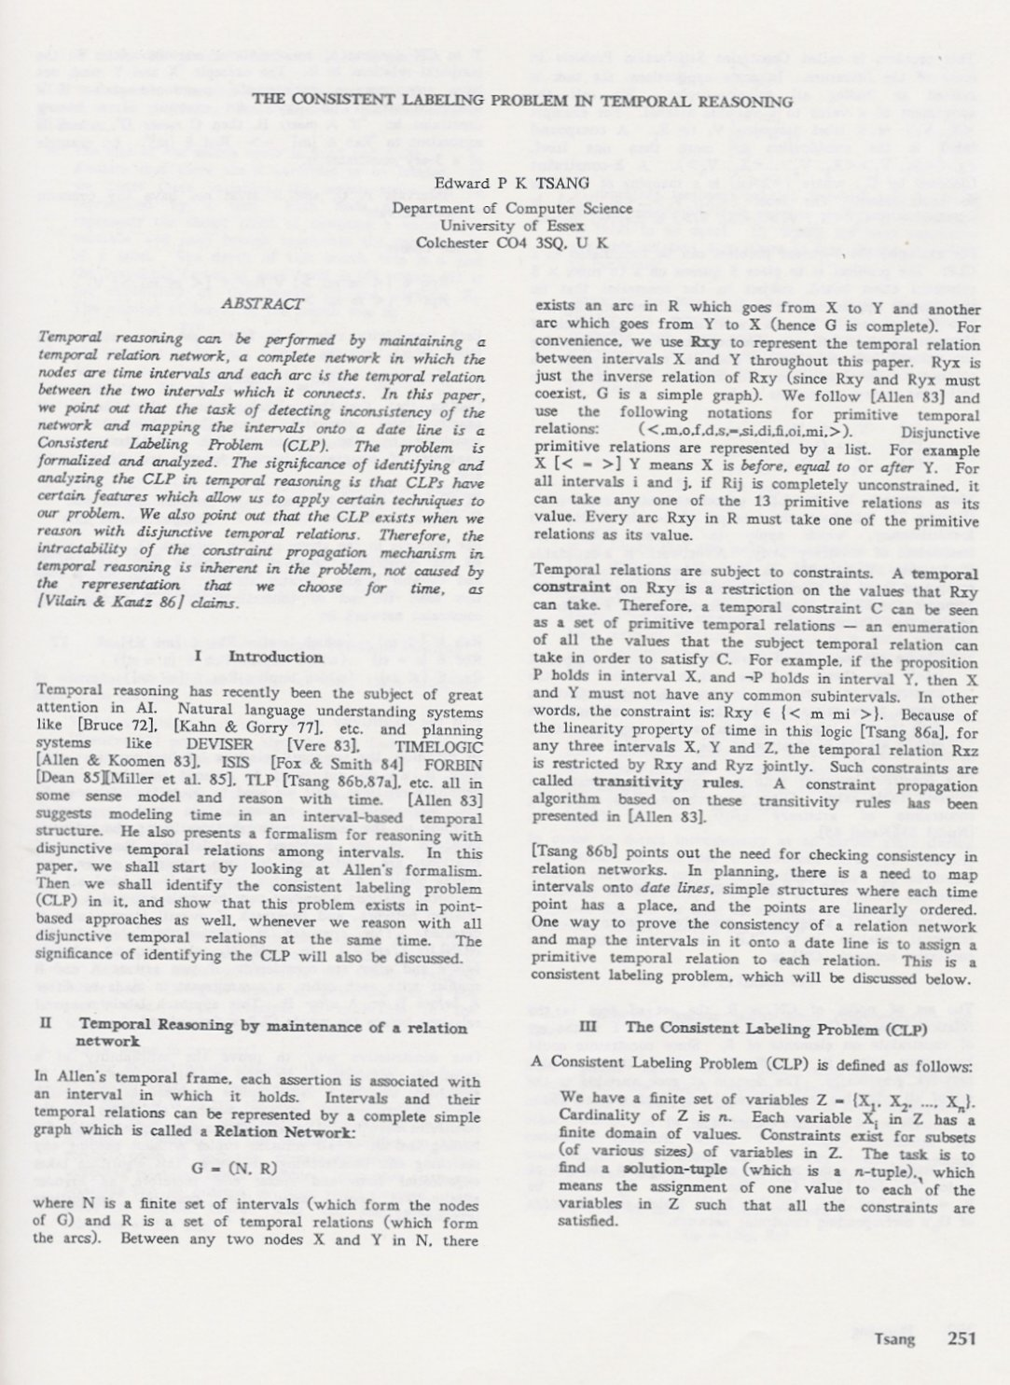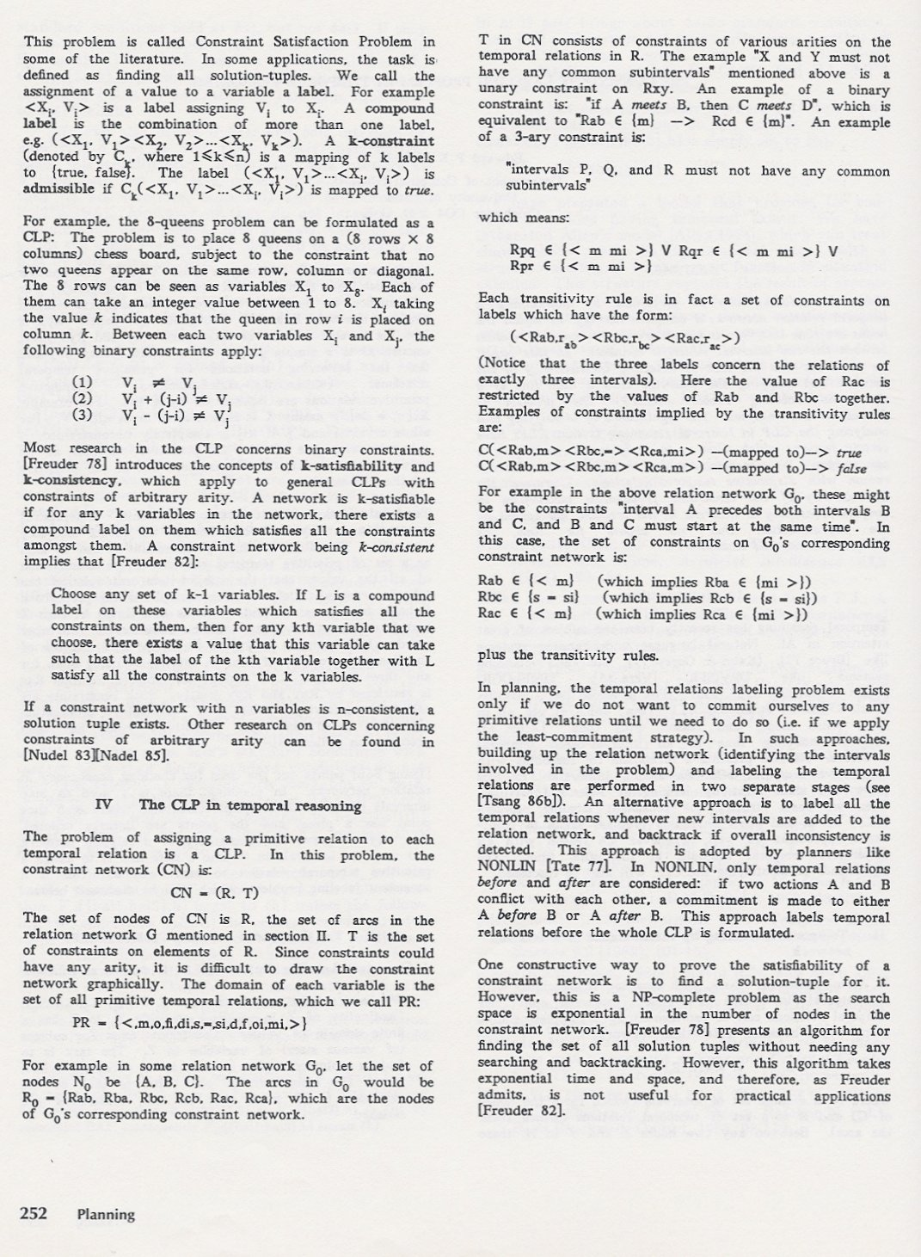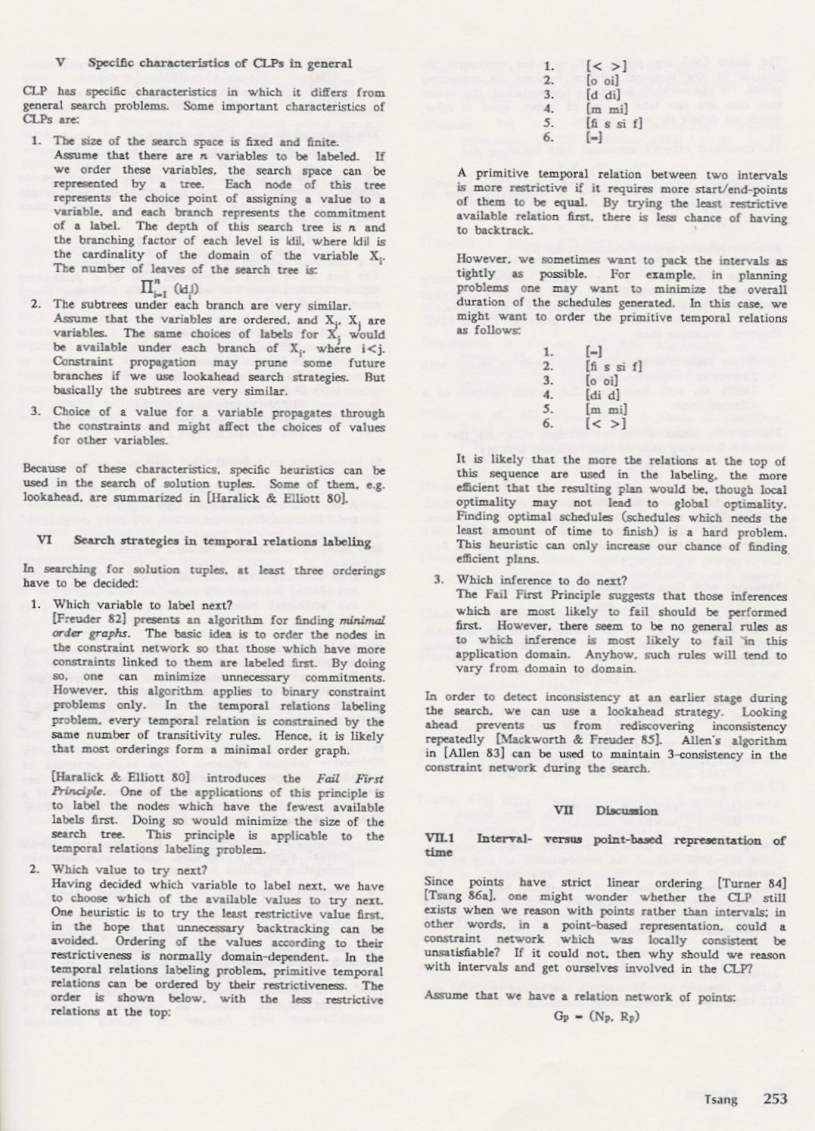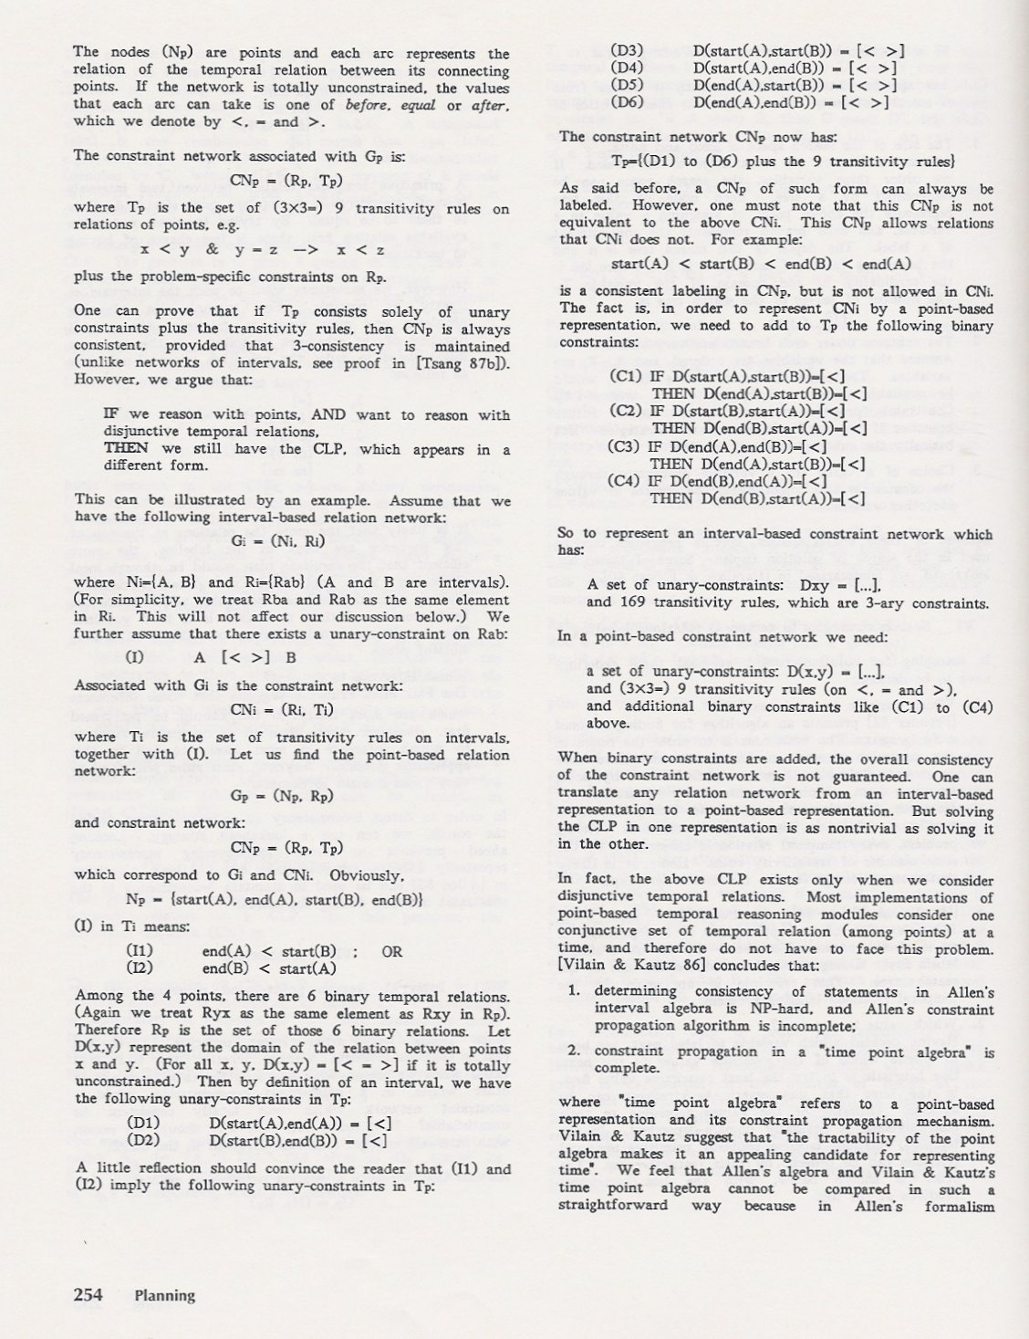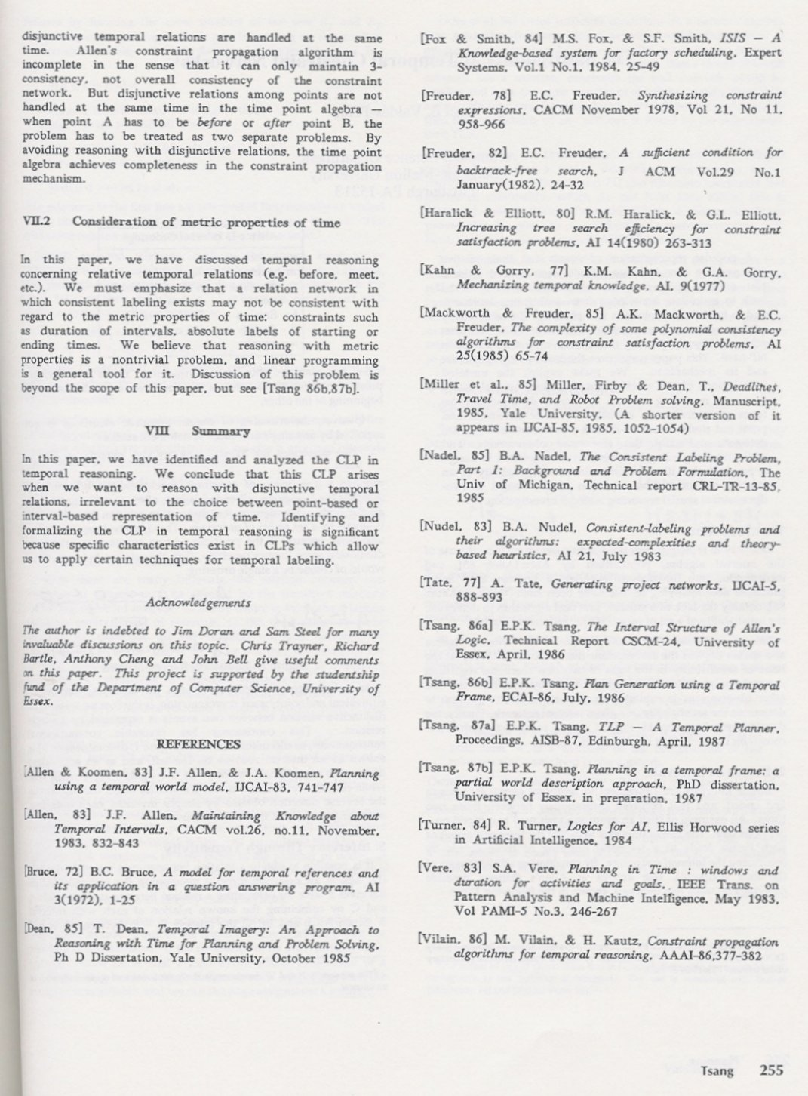
Tsang, E.P.K., The Consistent Labelling Problem In Temporal Reasoning, Proceedings, Sixth National Conference on Artificial Intelligence (AAAI-87), Seattle, July, 1987, 251-255

